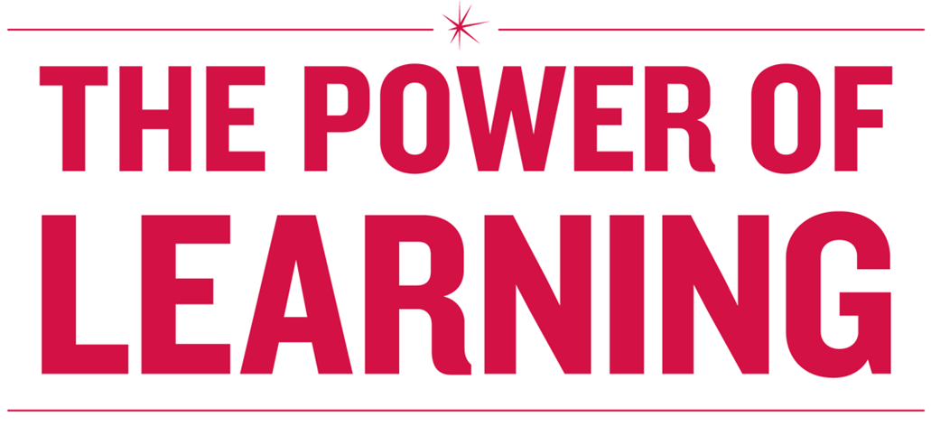

**POWER HOUR:**

**Rock Star Meetings**

# Core Competencies

# Lead, Facilitate, Contribute

* Host productive and engaging meetings.
* Create an environment where meetings and the contributions others provide at meetings are valued.
* Facilitate meetings in a way that promotes creative thinking.
* Determine how to contribute the most value to any meeting you attend.
* Create an environment that encourages the team to challenge the status quo; promote innovative ways of looking at problems and processes.

**Measures**

* Fewer post- and pre- meetings.
* Productive dialogue and conflict in meetings
* Employee Survey results show favorable and/or trending up, particularly Employee Engagement Index, Diversity Index and Supervisory Index.
* Team is making process improvements, sharing ideas and championing innovative approaches.
* Employees outside the organization want to work on the team (e.g. apply for open positions).

# Table of Contents

Table of Contents 3

Introduction: Why Do We Meet? 5

Warm Up Activity 7

The Meeting Canoe Model 8

Planning a Meeting 9

Types of Meetings 11

Roles and Responsibilities 12

Navigating Meeting Pitfalls 13

What Does a Huddle Look Like? 14

Monthly Meeting Template 18

Assess Your Current Weekly/Monthly Meeting 20

Setting Your Agenda 21

Appendix: Sample Team Agenda (Source: manager-tools.com) 23

Appendix: Meeting Planning Questions 24

Appendix: Meeting Effectiveness Assessment 25

Appendix: Bibliography and Additional Resources 26

**Learning Objectives**

Upon completing this workshop, you should be able to:

### Identify the structure and important elements of successful meetings

* Identify the types of meetings best suited for business needs

### Learn best practices for meeting leaders, contributors, and facilitators

* Assess the quality of current meetings (purpose, agenda, participant’s energy and attention)
* Design and implement a meeting agenda

**Agenda**

### Introductions

### Meeting Canoe Model

* Different Types of Meetings

### Roles and Responsibilities: Leadership, Contributors, and Facilitators

* Modeling of Rock Star Meetings
* Assess Your Current Meetings
* Setting the Agenda

# Introduction: Why Do We Meet?

*“We meet because people holding different jobs have to cooperate to get a specific task done. We meet because the knowledge and experience needed in a specific situation are not available in one head, but have to be pieced together out of the knowledge and experience of several people.”*

* Peter Drucker

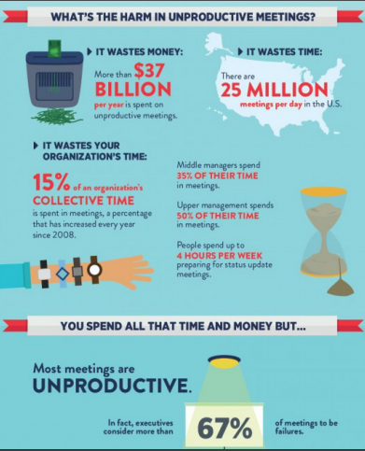

Inc. Magazine

Hosting and facilitating meetings that are productive require purpose, planning, and participation. Each person needs to be held accountable for making the meeting a success. Likewise, the leaders and facilitators of the meeting need to provide tools and use best practices to ensure participants leave meetings energized and action-oriented.

This workshop introduces models and tools to increase your comfort and confidence in holding meetings that accomplish specific work tasks and boost employee participation and engagement.

# Warm Up Activity

Recall a meeting where you left having a real sense of accomplishment:

*What made it good for you individually?*

Discuss the questions below with your group according to the role the facilitator assigns to you.

*If you’re a host, what do you think makes a meeting good for your participants?*

*What do you think makes a meeting bad?*

*If you’re a participant, what do you think hosts can do to make a meeting good or bad?*

# The Meeting Canoe Model

*“Success starts with conceiving of meetings as places where everyone does productive work.”*

* Dick & Emily Axelrod  
    *Let’s Stop Meeting Like This*

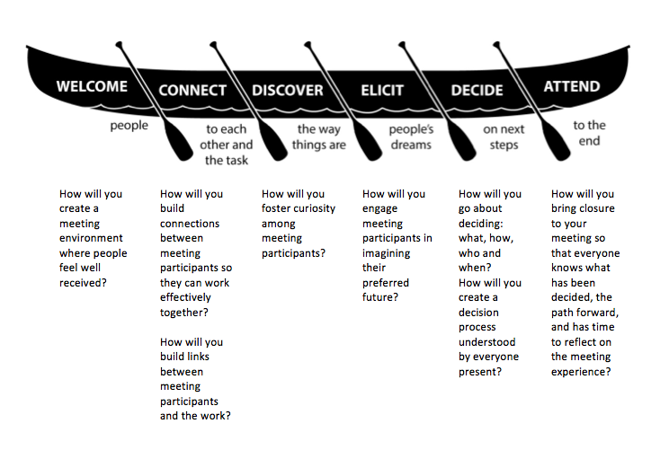

The Axelrod Group

In their book,*: Tools to Save Time and Get More Done*, Dick and Emily Axelrod illustrate a successful model for hosting productive, meaningful meetings. During their extensive research of what makes a meeting good; they conclude great meetings all have the same five attributes:

* Autonomy
* Meaning
* Challenge
* Learning
* Feedback

They implement these five attributes by following The Meeting Canoe Model when designing meetings.

# The Stages of the Meeting Canoe Model

**Stages**

|  |  |
| --- | --- |
| Welcome | * Effective meetings create a welcoming environment. * Creating a welcoming environment reduces perceived threats. * Welcoming helps create a safe environment so that work can be done. |
| Connect People to Each Other and the Task | * Personal connection builds trust; connection to the task releases energy. * Creating dialogue can help build connection to others and the task. Example dialogue questions are:   + Why did you say yes to attending this meeting?   + What do you want to create for yourself and others as a result of our work together?   + How will our work impact others?   + What will success require of you? * The context and the organization’s culture will help you determine how to connect people to each other. |
| Discover the Way Things Are | * Create a shared view of the reality you are facing. * Provide the opportunity for people to make sense of that reality.   + The facts: objective, verifiable data   + Your thoughts: how you interpret the facts   + Your feelings: how you feel about the facts |
| Elicit People’s Dreams | * Four ways to elicit people’s dreams:   + Find out what people care about   + Talk about the future as if it were the present   + Use the Arts to engage the creative side of your brain   + Take a break |
| Decide | * Be clear to all about who will be making the decision. * Be clear to all about how the decision will be made. * Three ways to help break an impasse:   + Thumbs-Up/Thumbs-Down   + Voting   + Decide what you can agree to right now |
| Attend to the End | * Review action items and to-do’s for each person in the meeting. * Create a road map to reach the next stage in planning your work. * Take time to reflect on your meeting and gather feedback about the meeting process. |

# Planning a Meeting

When planning a meeting it is important to keep the work that needs to be done at the forefront of the planning process. Using the following questions as a road map for your meeting agenda, helps develop a comprehensive meeting strategy.

1. **Is this meeting necessary?**

Do we need to:

* Share information that requires dialogue?
* Coordinate actions?
* Make decisions?
* Develop plans and strategies?

1. **What do we want to be different because this group of people meets?**

* Use the purpose to guide discussion and follow the Meeting Canoe Model

1. **Who needs to be in our crew?**

* Include people who have:
  + Information
  + Authority
  + Responsibility
  + Different thinking styles
  + A likelihood of opposing

1. **How do we get people to take ownership for the meeting?**

* Involve people in the process of creating the meeting. This may be an opportunity to suggest agenda items, determine priority of topics, or assist in the general design of the meeting.
* Involving the participants early in the meeting ensures continued participation and responsibility on the part of contributor’s for the meetings continued success.

1. **What type of meeting does this need to be?**

* It is important to differentiate between types of meetings when doing work.
* Types of meetings vary in length and formality

*What other types of meeting tools are needed to host a successful meeting?*

# Types of Meetings

*“We need to have multiple types of meetings and clearly distinguish between the various purposes, formats, and timing of those meetings.”*

* Patrick Lencioni  
    *Death by Meeting*

In an effort to scale back time spent in meetings, some managers try to only have one meeting a week. During this meeting everything from office birthday parties to what is the next strategic goal for the department is discussed during this meeting. This often results in a lackluster meeting that can quickly run over the allotted time.

The goal in having successful meetings is again, keeping the work purpose in mind, decide which type of meeting is necessary and following best practices to fit the meeting format. Below is a list of meeting types adapted from Patrick Lencioni’s book, *Death by Meeting: A Leadership Fable.*

|  |  |  |  |
| --- | --- | --- | --- |
| **Meeting Type** | **Time Required** | **Purpose and Format** | **Keys to Success** |
| Chats/Huddles | 5 – 30 minutes | To tackle a specific problem or issue – may be an informal discussion. | * Be conscientious of others’ time * Focus on the issue at hand * Ask for feedback |
| Weekly Tactical | 45-90 minutes | Review weekly activities and metrics, and resolve tactical obstacles and issues. | * Send out agenda in advance – keep reports about duties short * Postpone strategic discussions |
| 1:1 (Bi-monthly or monthly) | 30 minutes | Development of your staff. | * Provide direction and support but don’t micromanage * Prepare questions in advance to keep you on track with objectives and process. |
| Monthly Operations | 2 – 4 hours | Discuss, analyze, brainstorm, and decide up on critical issues affecting long-term success. | * Limit to one or two topics * Prepare and do research * Engage in good conflict |
| Strategic: Quarterly, Bi-Annually or Annually | 1 – 2 days | Review strategy, industry trends, competitive landscape, key personnel, team development | * Get out of the office if possible * Focus on work * Don’t over structure the schedule |

# Roles and Responsibilities

Meetings require each participant to understand the expectations and responsibilities of the role they play in the meeting. It is important to discuss the expectations for each role with meeting participants prior to the start of the meeting. Below is an adapted review from the book *Let’s Stop Meeting like This* of the different roles people can play in a meeting.

|  |  |  |
| --- | --- | --- |
| **Role** | **Responsibilities** | **Keys to Success** |
| Leader | * Convenes the meeting * Assures that the purpose for the meeting is clear and compelling * Assures the right people are present * Leads the meeting, making sure the group stays on task | * Use your power wisely * Invite criticism * Mine for conflict * Make sure the decision-making rules are clear * Be prepared for the meeting |
| Contributor | * Offers ideas and participates in discussion * Brings needed information to the meeting * Acts to facilitate the group’s work effectively | * Take responsibility for the outcomes * Speak your truth * Be open to others’ viewpoints * Be prepared for the meeting |
| Facilitator | * Assist the group in achieving its purpose * Take responsibility for timekeeping or posting information * Promotes all participants’ voices * Helps to resolve conflicts | * Think like a designer – involve participants in the flow of the meeting * Describe what you see and hear when impasses arise * Work to make sure everyone’s voice counts |

# Navigating Meeting Pitfalls

Even when everyone is aware of their roles and responsibilities and there is a great facilitator to move the discussion forward – pitfalls, deadlocks, and impasses can happen in meetings.

*What have you found to be helpful to navigating out of meeting pitfalls?*

**Navigating Meeting Pitfalls**

|  |  |
| --- | --- |
| **Problem** | **Helpful Action** |
| One person constantly talks | Paraphrase their message, ask for confirmation, ask for other opinions |
| Two people argue while others remain silent | “I think we know your viewpoints. I’d like to hear what others have to say.” |
| Two people are locked in conflict | Ask each person to state their understanding of the other person’s viewpoint. |
| The group is off on a tangent | “Is this the work we are supposed to be doing now?” Ask everyone’s opinion of this statement. |
| The group is deadlocked and unable to make a decision | “What would you like to do about the deadlock we are facing?” |
| You have an unclear understating of decisions reached or next steps | “I’m not clear on what we just decided” or “I don’t know what the next steps are” |

# What Does a Huddle Look Like? – Research Manager

**Background Information**

The new research analysis team needs a dedicated workspace. The top boss has said this is a priority and approved using a 2500 square feet storage facility to convert into the needed workspace. He has asked you to work with other team members to decide on how this can best be done within a reasonable budget. You need to meet with your team to create a preliminary proposal before moving forward.

**Research Manager – Leader**

You have just been appointed the manager of the new research analysis team. You are excited for this great opportunity to review the data your company has collected and find improvements for processes. However, company space is tight. You were just told by your boss that you will have to use renovated storage facility space for your team’s workspace. This is not the most welcoming space for your new team of 12 to start making great improvements to the organization. It isn’t insulated very well, has one dingy window, and to use the bathrooms or kitchen facilities your team has to go outside the storage facility and into the building across a parking lot.

A lot needs to be done to make the space workable. You envision an open space concept to the work area so collaboration can happen between researchers for the best improvements possible. You’re glad that the storage facility is large because you plan to use every square inch! Also, your team is going to need all new top-of-the-line computer equipment to fulfill their mission.

You know you have a lot to get done and hope that the Facilities Manager will be a good ally to helping you renovate the space as you see fit. You also know you are going to have to fight for the things you think are truly necessary and make a few compromises with the Budget Administrator. You see the two of them and think if you can speak to them for just a few minutes you may be able to get a good start on the renovation plan.

|  |  |  |
| --- | --- | --- |
| **Item** | **Price** | **Priority** |
| Two bathrooms installed | $10,000.00 |  |
| New insulation – 2500 square feet | $6,250.00 |  |
| Electrical wiring to support open concept workflow | $11,500.00 |  |
| 8 large work tables wired for computers | $3,000.00 |  |
| 12 new top-of-the-line desktops | $24,000.00 |  |
| 12 additional monitors | $10,800.00 |  |
| Kitchen Area: Fridge, sink, coffee maker, table , microwave etc. | $15,000.00 |  |
| Small Conference Room | $10,000.00 |  |
| **Total** | **$90,550.00** |  |

# What Does a Huddle Look Like? – Budget Administrator

**Background Information**

The new research analysis team needs a dedicated workspace. The top boss has said this is a priority and approved using a 2500 square feet storage facility to convert into the needed workspace. He has asked you to work with other team members to decide on how this can best be done within a reasonable budget. You need to meet with your team to create a preliminary proposal before moving forward.

**Budget Administrator– Contributor**

You know this renovation of the storage facility into office space is going to be a huge expense. However, you have been tasked to make sure it is done in the most fiscally responsible way. You know the team of 12 will need a good bit of the storage facility for their workspace, but don’t think they will need the whole 2500 square feet. If the team only uses 1500 square feet it will cut down on the cost for insulation.

It would make sense for the space to have its own bathroom facilities so that the team doesn’t have to constantly transition between the two buildings. The Research Manager will also probably need a private office or conference room to discuss performance matters.

You also know the storage facility currently has six 4’ X 2’ cubicles that can be used for the new workspace. Also, Using less space and cubicles will cut down on the need for extensive electrical wiring for the workspace. Finally, there are also 6 old desktops that IT could refurbish for the new team.

While this is still quite an undertaking, using the materials available will keep the total cost at an acceptable level.

You have been thinking about the total budget for the renovation when you the Research Manager asks you over for a quick chat about where everyone stands on the renovation project.

|  |  |  |
| --- | --- | --- |
| **Item** | **Price** | **Priority** |
| Two bathrooms installed | $10,000.00 |  |
| New insulation – 1500 square feet | $3,750.00 |  |
| Electrical wiring to support cubicles | $8,000.00 |  |
| 6 additional cubicles | $3,500.00 |  |
| 6 additional new desktops | $4,200.00 |  |
| Small Conference Room/Office | $10,000.00 |  |
| **Total** | **$39,450.00** |  |

# What Does a Huddle Look Like? – Facilities Manager

**Background Information**

The new research analysis team needs a dedicated workspace. The top boss has said this is a priority and approved using a 2500 square feet storage facility to convert into the needed workspace. He has asked you to work with other team members to decide on how this can best be done within a reasonable budget. You need to meet with your team to create a preliminary proposal before moving forward.

**Facilities Manager – Contributor**

You are not looking forward to having to give up any of your storage facility to workspace. You have so much stuff in the storage facility, that it will be a real undertaking to remove it and find additional spaces for storage.

It is still the standard procedure to keep all documents for 3 years for auditing purposes. The cut down on the storage facility space will now make this job much more difficult. There will be some pluses, like the removal of the cubicles and computers. But the vast amount of storage material will still need to be reshuffled. You are hoping to only have to give up 1000 square feet of your facility just for workspace – if the new team needs anything else they can use the other building.

You also want to make a push for an outside contracting team to put together the renovation so your team can focus on reorganizing the storage material. This would be an added cost to the budget and one you are sure hasn’t been thought of by the Research Manager or the Budget Administrator.

The Research Manager had just asked for a brief meeting huddle on the project. You stop by to see what you may be able to salvage of your storage facility.

|  |  |  |
| --- | --- | --- |
| **Item** | **Price** | **Priority** |
| New insulation – 1000 square feet | $2,500.00 |  |
| Electrical wiring to support cubicles | $8,000.00 |  |
| 6 additional cubicles | $3,500.00 |  |
| 6 additional new desktops | $4,200.00 |  |
| Contractor for work | $15,000.00 |  |
| **Total** | **$33,200.00** |  |

# What Does a Huddle Look Like? – Facilitator

**Background Information**

The new research analysis team needs a dedicated workspace. The top boss has said this is a priority and approved using a 2500 square feet storage facility to convert into the needed workspace. He has asked you to work with other team members to decide on how this can best be done within a reasonable budget. You need to meet with your team to create a preliminary proposal before moving forward.

**Impartial Facilitator/Observer**

Review all three roles and then observe as the meeting starts. When you feel the parties are stuck or need help, offer direction, guidance and support to move the meeting along.

Helpful guides to best facilitate the meeting:

1. The Meeting Canoe Stages – Pg. 8
2. Navigating Out of Meeting Pitfalls – Pg. 12

Record the two decisions that the team makes and be ready to report out about what happened.

1. What is the estimated overall budget for the conversion?
2. How much of the storage facility will be used for the workspace?

# Monthly Meeting Template

|  |  |  |  |  |
| --- | --- | --- | --- | --- |
| Monthly Team Meeting | |  | | --- | | March 17, 2016 | | 8:30 – 10:00 AM | | LC3 1314 | |

|  |  |  |  |
| --- | --- | --- | --- |
| **Meeting called by:** | Jane Andrews, Director | **Type of Meeting:** | Monthly - Operations |
| **Facilitator:** | Frank Davis | **Note taker:** | Jose Garcia |

|  |  |
| --- | --- |
| **Timekeeper:** | Erika Reynolds |
| **Attendees:** | Salma Cruise, Frank Davis, Jose Garcia, Andy Jackson, Erika Reynolds |
| **Please review:** | Attachments: Draft Evaluation Survey, Reporting Software New Requirements Meeting Agenda/Process |
| **Please bring:** | Weekly Priorities & Issues, Hurdles & Opportunities |

## Agenda Items

|  |  |  |
| --- | --- | --- |
| **Topic** | **Presenter** | **Time allotted** |
| * Welcome – Agenda Overview | Jane Andrews | 5 minutes |
| * Safety Message | Susan Reynolds | 10 minutes |
| * Highlights from last week? | Jane Andrews, All | 5 minutes |
| * Round Robin – Top 3 Priorities for coming month in 60 seconds | All | 10 minutes |
| * Issues: |  |  |
| * + Coverage for peak period and storm: June through August; Volunteers? | Salma Cruise | 10 minutes |
| * + New front line training program     - Launch date, enrollment report     - Manager communication templates     - Evaluation survey (input from team) | Andy Jackson | 15 minutes |
| * + Update and impacts of new software reporting system | Jose Garcia | 10 minutes |
| * To-Do’s: Actions/Owner/Deadlines & Deliverables | Frank Davis | 10 minutes |
| * Closing: Hurdles and Opportunities: Roundtable Discussion | All | 15 minutes |

## Important Information

|  |  |  |
| --- | --- | --- |
| Calendar: | April 7 2:00 – 3:30  LC2 106 | * Reporting Software New Requirements Meeting,  (see attached Six Thinking Hats Process, Goals and Agenda) |
| April 18 8:30 – 10:00  LC3 1314 | * Monthly Team Meeting |
| April 21 1:00 – 2:30  LC2 113/114 | * Road Show—Please make a strong showing! |
| May 27 | * Memorial Day Holiday |
| June 7 – 14 | * Andy on vacation |
| FYI: | June 21 – 25 | * Mid-year reviews due to Jane by 5 pm 6/25 |
| July 17 | * Employee Picnic at the Museum of Science and Industry |
| August 8 | * Charity Golf Event at Cantigny, see Frank to purchase tickets |

# Meeting Agenda Activity

Reviewing the agenda on the previous page, discuss the questions below with your group.

*What are the best practices of meetings reflect in the monthly meeting agenda?*

*How can Jane (leader) and Frank (facilitator) build accountability into the meeting?*

*What are some of the things Jane or Frank could do to keep the meeting from going off-track?*

# Assess Your Current Weekly/Monthly Meeting

Considering the Meeting Canoe model, planning, and roles necessary to have a successful meeting, take a moment to assess the last meeting you attended (as a leader, contributor, or facilitator) by answering the questions below:

**Name of Your Meeting:** _____________________________________________________

**Circle the best response**.

Everyone present at this meeting understands the meeting’s purpose.

Agree Neither agree nor disagree Disagree

**Using the table below, please check the box corresponding to your answer.**

|  |  |  |  |  |  |
| --- | --- | --- | --- | --- | --- |
|  | **100%** | **75%** | **50%** | **25%** | **< 10%** |
| Of all the times this meeting is held, what percent of the time does the meeting advance the work of your organization? |  |  |  |  |  |
| Of all the times this meeting is held, what percent of the time are the right people included in the meeting? |  |  |  |  |  |
| Of all the times decisions occur in this meeting, what percent of the time is the decision-making process clear to everyone present? |  |  |  |  |  |

**Using the table below, please check the box corresponding to your answer.**

|  |  |  |  |  |
| --- | --- | --- | --- | --- |
|  | **Always** | **Sometimes** | **Rarely** | **Never** |
| Of all the times this meeting is held, how often does valuable learning occur? |  |  |  |  |
| Do you feel welcome in this meeting? |  |  |  |  |
| Do you feel connected to this meeting’s task? |  |  |  |  |
| When issues arise in the meeting that prevent the group from achieving its purpose, how often does the group work to resolve these issues? |  |  |  |  |
| Of all the times this meeting takes place, how often does the group discuss whether this meeting is time well spent? |  |  |  |  |

When you have finished taking this quick assessment, discuss your assessment and the strategies you plan to take.

*What is a realistic change?*

*What resources might you need?*

*Where do you begin?*

# Setting Your Agenda

Using the template below, implement the best practices for planning the next session of the meeting you chose to evaluate using the assessment.

|  |  |  |  |  |
| --- | --- | --- | --- | --- |
| My Meeting | |  | | --- | | Date: | | Time: | | Location: | |

|  |  |  |  |
| --- | --- | --- | --- |
| **Meeting called by:** |  | **Type of Meeting:** |  |
| **Facilitator:** |  | **Note taker:** |  |

|  |  |
| --- | --- |
| **Timekeeper:** |  |
| **Attendees:** |  |
| **Please review:** |  |
| **Please bring:** |  |

## Agenda Items

|  |  |  |
| --- | --- | --- |
| **Topic** | **Presenter** | **Time allotted** |
| * Welcome – Agenda Overview |  |  |
|  |  |  |
|  |  |  |
|  |  |  |
| * Issues: |  |  |
|  |  |  |
|  |  |  |
|  |  |  |
| * To-Do’s: Actions/Owner/Deadlines & Deliverables |  |  |
| * Closing: Hurdles and Opportunities: Roundtable Discussion |  |  |

## Important Information

|  |  |  |
| --- | --- | --- |
| Calendar: |  |  |
|  |  |
|  |  |
|  |  |
|  |  |
| FYI: |  |  |
|  |  |
|  |  |

# Group Debrief

What went well?

What was difficult?

What will you do differently as a result of this training?

**Peer Coaching Agreement**

I agree to meet with __________________________________ at this date and time _____________________________________ to discuss how I have implemented these changes in my meetings.

# Appendix A: Sample Team Agenda (Source: manager-tools.com)

|  |  |  |  |  |
| --- | --- | --- | --- | --- |
| My Meeting | |  | | --- | | Date: | | Time: | | Location: | |

|  |  |  |  |
| --- | --- | --- | --- |
| **Meeting called by:** |  | **Type of Meeting:** |  |
| **Facilitator:** |  | **Note taker:** |  |

|  |  |
| --- | --- |
| **Timekeeper:** |  |
| **Attendees:** |  |
| **Please review:** |  |
| **Please bring:** |  |

## Agenda Items

|  |  |  |
| --- | --- | --- |
| **Topic** | **Presenter** | **Time allotted** |
| * Welcome – Agenda Overview |  |  |
|  |  |  |
|  |  |  |
|  |  |  |
| * Issues: |  |  |
|  |  |  |
|  |  |  |
|  |  |  |
| * To-Do’s: Actions/Owner/Deadlines & Deliverables |  |  |
| * Closing: Hurdles and Opportunities: Roundtable Discussion |  |  |

## Important Information

|  |  |  |
| --- | --- | --- |
| Calendar: |  |  |
|  |  |
|  |  |
|  |  |
|  |  |
| FYI: |  |  |
|  |  |
|  |  |

# Appendix: Meeting Planning Questions

1. Is this meeting necessary?
2. What do we want to be different because this group of people meets?
3. Who needs to be in the meeting?
4. How do we get people to take ownership of the meeting?
5. What type of meeting does this need to be?

# Appendix: Meeting Effectiveness Assessment

Circle the best response.

Everyone present at this meeting understands the meeting’s purpose.

Agree Neither agree nor disagree Disagree

Using the table below, please check the box corresponding to your answer.

|  |  |  |  |  |  |
| --- | --- | --- | --- | --- | --- |
|  | **100%** | **75%** | **50%** | **25%** | **< 10%** |
| Of all the times this meeting is held, what percent of the time does the meeting advance the work of your organization? |  |  |  |  |  |
| Of all the times this meeting is held, what percent of the time are the right people included in the meeting? |  |  |  |  |  |
| Of all the times decisions occur in this meeting, what percent of the time is the decision-making process clear to everyone present? |  |  |  |  |  |

Using the table below, please check the box corresponding to your answer.

|  |  |  |  |  |
| --- | --- | --- | --- | --- |
|  | **Always** | **Sometimes** | **Rarely** | **Never** |
| Of all the times this meeting is held, how often does valuable learning occur? |  |  |  |  |
| Do you feel welcome in this meeting? |  |  |  |  |
| Do you feel connected to this meeting’s task? |  |  |  |  |
| When issues arise in the meeting that prevent the group from achieving its purpose, how often does the group work to resolve these issues? |  |  |  |  |
| Of all the times this meeting takes place, how often does the group discuss whether this meeting is time well spent? |  |  |  |  |

*What can I do to improve upon this meeting?*

*What resources might I need?*

*Where do I begin?*

# Appendix: Bibliography and Additional Resources

* *Death by Meeting: A Leadership Fable…About the Most Painful Problem in Business* (Patrick Lencioni)
* *“*Half of All Meetings Are Unproductive. Is There a Fix?” (Marketplace, Nancy Kohen)
* *Let’s Stop Meeting Like This: Tools to Save Time and Get More Done*(Emily and Dick Axelrod)

[Free Management Library](http://managementhelp.org/)

Provides free, easy-to-access, online articles. Over the past 15 years, the Library has grown to be one of the world's largest well-organized collections of these types of articles and resources.

[AxelrodGroup.com](http://axelrodgroup.com/)

Research, articles, blogs and insights from authors, Emily and Dick Axelrod

[TableGroup.com](http://www.tablegroup.com)  
Resources for team building, leadership, and employee engagement.

[Manager-tools.com](http://www.manager-tools.com)    
An online resource that provides podcasts, templates and tools for manager development.

[The](http://lms.exeloncorp.com/plateau/user/deeplink_redirect.jsp?linkId=ITEM_DETAILS&componentID=E-W-ALL-SITLEAD0304&componentTypeID=TRAINING&revisionDate=1415818380000) Art and Science of a 1:1 *at ComEd*

This two-hour workshop gives managers and supervisors tools to become skillful and effective communicators and coaches with their direct reports, colleagues and bosses. The workshop reviews best practices and tools for conducting a 1:1 meeting for employee development.